VENANGO TECHNOLOGY CENTER
JOINT COMMITTEE
1 Vo-Tech Drive
Oil City, Pennsylvania 16301

MINUTES

March 1, 2021

The regular meeting of the Venango Technology Center Joint Committee was held this evening in the Conference Room of the Venango Technology Center, 1 Vo-Tech Drive, Oil City, PA 16301. Mr. Come called the meeting to order at seven o’clock (7:00) p.m.

Mr. Come asked the members to pause for a moment of silence.

Mr. Come asked the members to stand for the pledge of allegiance.

Roll Call: Present: Todd Carson, Robert Blauser, James Disque, Mark Marterella, Andy Boland,
Shari Neely, Don Judy, James Come (zoom)

Absent: Troy Johnston, Jeff Thomas

Also Present: Mr. Mario Fontanazza, Mrs. Stephanie Keebler (zoom)

Mr. Come stated the Joint Committee members had received copies of the Minutes of the February 1, 2021 meeting in the mail. He asked if there were any additions, corrections or deletions.

Mr. Carson, seconded by Mr. Marterella, moved to approve the Minutes of the February 1, 2021 meeting as submitted.

Roll Call: Ayes: Todd Carson, Robert Blauser, James Disque, Mark Marterella, Andy Boland,
Shari Neely, Don Judy, James Come

Nayes: None, motion carried.

The Treasurer and Secretary’s Report as of 3/1/21 were submitted for information.

Mr. Disque, seconded by Mr. Carson, moved to accept the Treasurer and Secretary’s Report as of 3/1/21 as submitted.

The motion was unanimously approved.

A list of bills from 2/2/21 – 3/1/21 in the amount of $483,258.53 was presented for approval.

Mr. Carson, seconded by Mr. Disque, moved to approve the list of bills as presented.

Roll Call: Ayes: Todd Carson, Robert Blauser, James Disque, Mark Marterella, Andy Boland,
Shari Neely, Don Judy, James Come

Nayes: None, motion carried.

Under Communications, Mr. Fontanazza discussed the Professional Advisory Committee. He also discussed the Calendar of Events for the month of February and the Monthly Enrollment Report as of 3/1/21 were submitted.

Mr. Come requested approval of the action items as presented. Item 8. a) ii.- iv. in one motion.

Mr. Carson, seconded by Mr. Disque, moved to approve action items ii.- iv. as follows:

- Approve additions to Occupational Advisory Committees.
- Approve Mark Kuhar, of Kuhar Law, LLC, as labor counsel at a rate not to exceed $215.00 per hour.
- Approve school calendar for 2021-2022.
- Approve NOCTI waiver for the 2020-2021 school year.

Roll Call: Ayes: Todd Carson, Robert Blauser, James Disque, Mark Marterella, Andy Boland,
Shari Neely, Don Judy, James Come

Nayes: None, motion carried.

Mr. Fontanazza reviewed his Issues/Activities for February 2021.

Mr. Come asked if there was any old business.

None was noted.

Under New Business, Mr. Come requested approval of two action items as follows:

- Action: Approve a three year lease with Pitney Bowes for the postage meter at a cost not to exceed $707.37 paid quarterly.
- Action: Approve Carol Miller to tour an apprentice program in Wheeling West Virginia at a cost not to exceed $500.00. Funding – Local

Mr. Disque, seconded by Mr. Marterella, moved to approve the new business action items as presented.

Roll Call: Ayes: Todd Carson, Robert Blauser, James Disque, Mark Marterella, Andy Boland,
Shari Neely, Don Judy, James Come

Nayes: None, motion carried.

Upon motion by Mr. Disque, seconded by Mr. Carson, the meeting adjourned at eighteen minutes past seven (7:18) p.m.

Recorded by
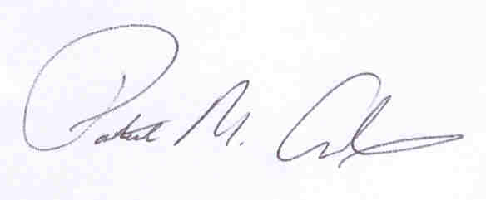
Patrick M. Adams
Secretary, Joint Committee

